[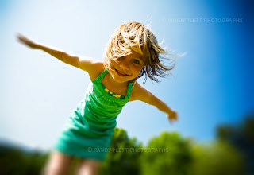](http://1.bp.blogspot.com/_c_oCoDXYEuc/TBr_4Pfao5I/AAAAAAAAAPE/iZSkG1FwzVU/s1600/children-fun-outdoors.jpg)

Oh I scaled those lofty mountains,

And plunged deep into ocean’s den,

I scathed the crusts of the snowy tundra,

And wandered in the Sahara, under the raining sun;

I hunted with the lions,

And hopped with the hares,

I soared with the eagles,

Like gulls, dived to hunted despair;

Bears and me, stole honey form the hornets,

Butterflies and me, danced along rivulets,

Sunflowers and me, raced from sun dawn to sun down,

Life didn’t care, and I cared no less;

Oh how I loved to play with myself,

Throw a ball high and go play fetch,

Oh how I loved talking to myself,

Sending postcards to myself everyday;

When I was Young!!